Subject | Timings | Activity
PE | 30 mins | 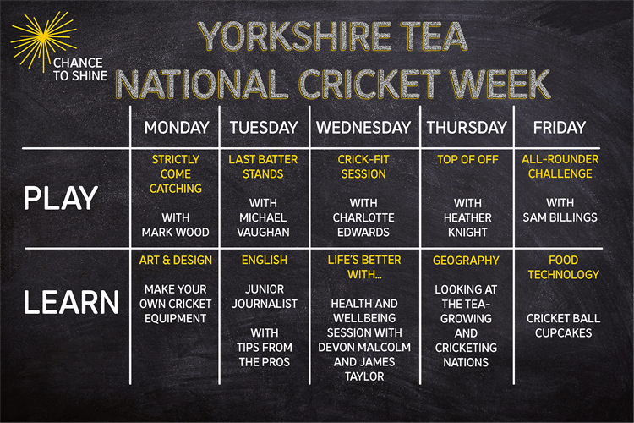  Click on the picture to take you to the activities for NATIONAL CRICKET WEEK.  We have a subscription to Online PE lessons, called Real PE  You need to enter the address:  home.jasmineactive.com  Then enter the email address:  parent@brockenhur-1.com  Password: brockenhur
Mental Maths | 5-10 minutes | See Maths
Maths | 45 minutes | White Rose Website. Summer 1 Week 7 Day 3  https://whiterosemaths.com/homelearning/year-3/  LO: TO calculate fractions from objects
Spellings | 15 Minutes | Spelling Shed - test yourself  Your spellings this week; quarter, possible, peculiar, heard, guard, eight, consider, century, breathe, accidentally  Play on spelling shed
Writing | 30 minutes | See English - Instead of doing the tasks that they suggested, try mine.
Reading |  | The Man Who Stole a Mountain  Open up the questions, then press the play button (top right). It sends you to a youtube link where the poem is read.  The reading and answering questions should take you about 2 sessions.  I’ve added a 2nd poem in case you have finished the first book.
Art | 1 hour | Art  https://www.youtube.com/watch?v=ExeekGarOzo

