Timetable
Subject | Timings | Activity
PE | 30 mins | 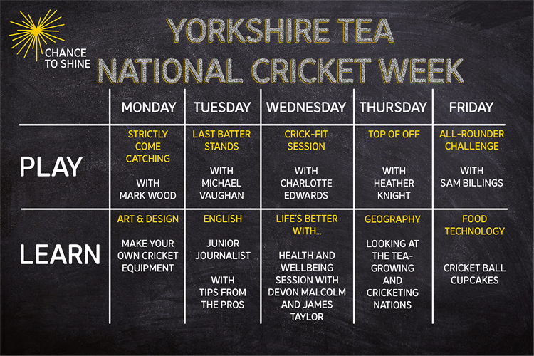  Click on the picture to take you to the activities for NATIONAL CRICKET WEEK.  We have a subscription to Online PE lessons, called Real PE  You need to enter the address:  home.jasmineactive.com  Then enter the email address:  parent@brockenhur-1.com  Password: brockenhur
Mental Maths | 5-10 minutes | See Maths
Maths | 45 minutes | White Rose Website. Summer 1 Week 8 Day 2  https://whiterosemaths.com/homelearning/year-3/
Spellings | 15 Minutes | Spelling Shed  Your spellings this week; quarter, possible, peculiar, heard, guard, eight, consider, century, breathe, accidentally  Play on spelling shed
Writing | 30 minutes | LO: To sequence our story walk from yesterday  For this lesson, we will sequence the places that you visited yesterday and what you saw.  Talk through your walk with somebody, this helps get your ideas organised.  I have given you some templates of storyboards that you can use.  These are great but can be time-consuming. So draw for 15 minutes (stick people are fine), then write for 15 minutes, making sure you write in each box. Add details with the time you have left.  Use your descriptive sentences from day three.  Talk through your walk with somebody, this helps get your ideas organised.  Alternatively - if you want to draw a map of your walk and annotate it, using the descriptive sentences you can.
Reading |  | The Man Who Stole a Mountain (2)  If you have finished the first section, then I have added the 2nd part, if not, carry on listening and enjoying the text.  Open up the questions, then press the play button (top right). It sends you to a youtube link where the poem is read.  The reading and answering questions should take you about 2 sessions.
Spanish | 1 hour | https://classroom.thenational.academy/lessons/to-be-able-to-describe-the-weather-in-spanish/activities/1  Learn Spanish.

