Timetable
Subject | Timings | Activity
PE | 30 mins | 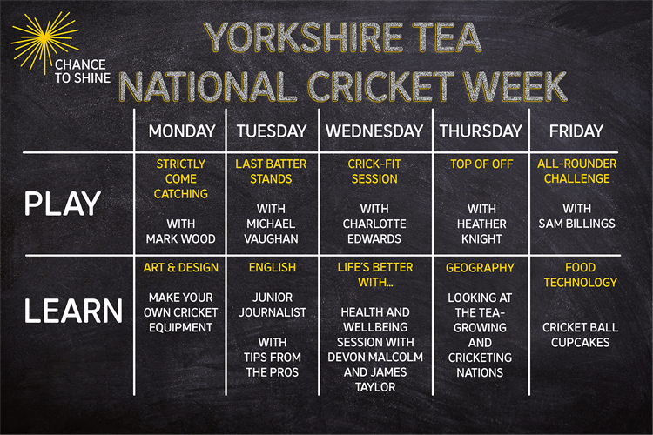  Click on the picture to take you to the activities for NATIONAL CRICKET WEEK.  We have a subscription to Online PE lessons, called Real PE  You need to enter the address:  home.jasmineactive.com  Then enter the email address:  parent@brockenhur-1.com  Password: brockenhur
Mental Maths | 5-10 minutes | See Maths
Maths | 45 minutes | TT Rock Stars
Spellings | 15 Minutes | Spelling Shed  Your spellings this week; quarter, possible, peculiar, heard, guard, eight, consider, century, breathe, accidentally  Play on spelling shed
Writing | 30 minutes | 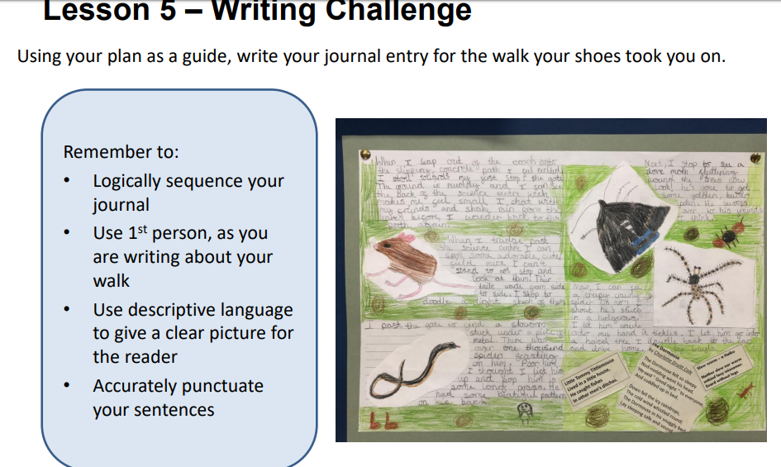
Reading |  | The Man Who Stole a Mountain (2)  If you have finished the first section, then I have added the 2nd part, if not, carry on listening and enjoying the text.  Open up the questions, then press the play button (top right). It sends you to a youtube link where the poem is read.  The reading and answering questions should take you about 2 sessions.
Art | 1 hour | You need coloured card for this  https://www.youtube.com/watch?v=37EfnkTHwMQ  Sketching task  https://www.youtube.com/watch?v=Krab3DvgW_c

