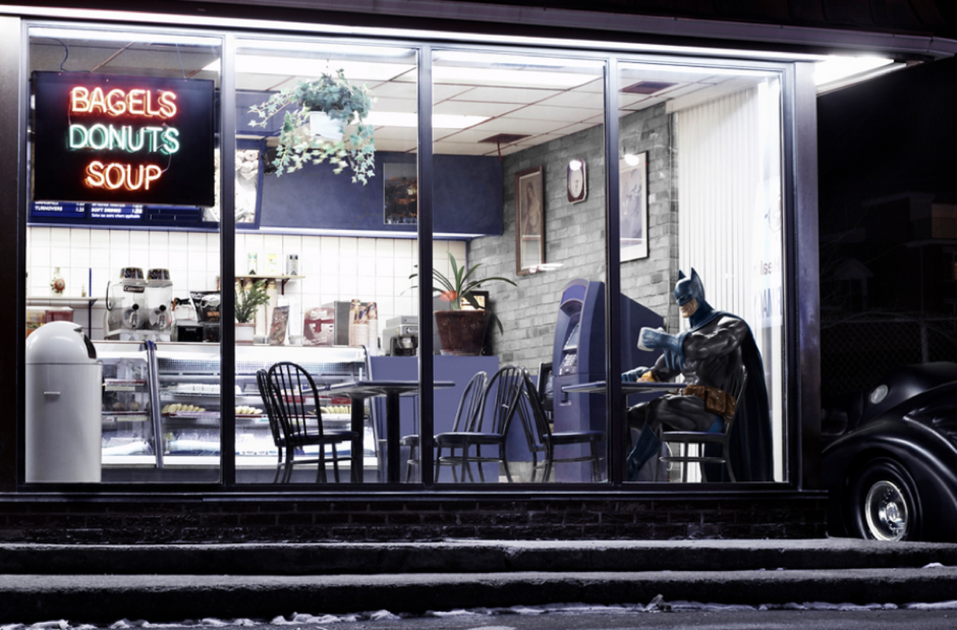
Story Starters
Batman’s Evening Off?

After work, Batman always called in at his favourite café in Gotham City. We all have different ways of relaxing; a game of sport, watching television, going for a bike-ride…Batman’s was enjoying a steaming hot cup of coffee whilst reading the newspaper.
Batman looked forward to having an evening off, however evenings off didn’t always tend be that relaxing.
Ring ring…Ring ring…Ring ring…There was a call from the phone behind the counter…

