The Very Hungry Caterpillar - Activities
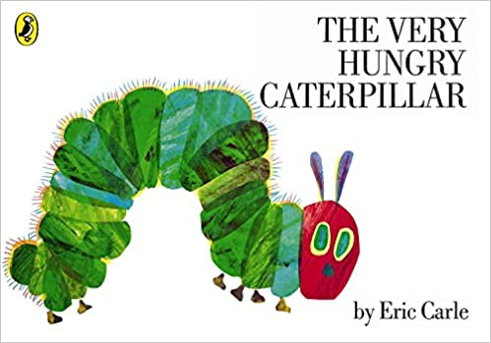

Choose any number of activities from the table below to do with your child over the course of the week.
Literacy Activities | - Listen to The Very Hungry Caterpillar read by Eric Carle:  https://www.youtube.com/watch?v=vkYmvxP0AJI  - Watch this animation of The Very Hungry Caterpillar  https://www.youtube.com/watch?v=75NQK-Sm1YY  - The very hungry caterpillar loves to eat lots of different foods. What is your favourite food? Draw a picture of your favourite food and writ e a sentence to tell us about it.  - In the story the caterpillar eats different foods each day. Can you remember the seven days of the week? Draw a picture and write a sentence about something you do each day?  - Can you find out about the lifecycle of a butterfly? You could draw a picture of it and label it.  - Can you keep a fruit diary – what different fruits do you eat each day? Could you try a new fruit?  - Write your own hungry caterpillar story, but change the fruit. Ask your grown up to help you write:  On Monday he ate through 1 _____  On Tuesday he ate through 2 _____ etc.  - Write a book review for the story.  - Do you have any other books by Eric Carle to read? If not, there are lots on YouTube
Creative ideas | - Make your own hungry caterpillar:  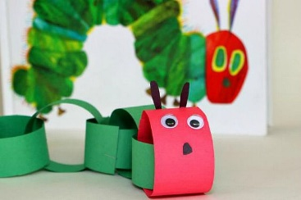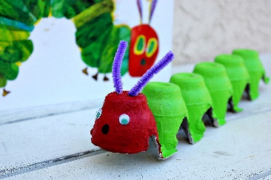  - Create your own front cover for the story using fingerprints  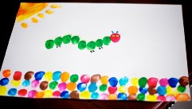  - Paint a symmetrical butterfly:  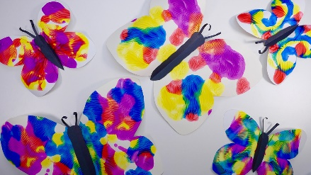  - Hand butterflies:  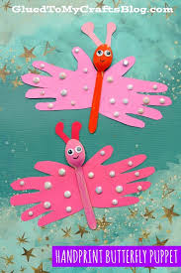  - Make a Hungry Caterpillar lift the flap book  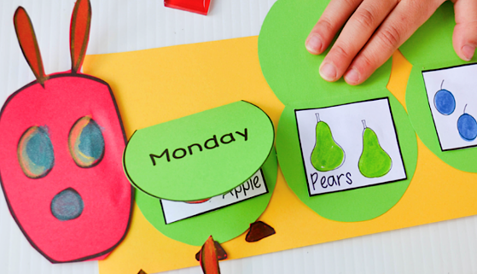
Science Activities | - Research the life cycle of other animals  - Go on a caterpillar hunt in your garden or out in the forest. Can you spot any butterflies too?  - Drinking Nectar Activity
Sing some songs | - Five Little Caterpillars:  https://www.youtube.com/watch?v=v5ZCw9cUEq0  - Little Arabella Miller:  https://www.youtube.com/watch?v=Y-Xk3ZsSFqg  - Wiggly Woo:  https://www.bbc.co.uk/teach/school-radio/nursery-rhymes-wiggly-woo/zvj8gwx  - If I were a butterfly:  - https://www.youtube.com/watch?v=xbJUynRN0js
Cooking ideas | - Make Fruit pizzas – see recipe sheet  - The Very Hungry Caterpillar – sandwiches  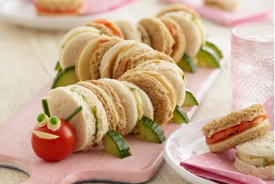  - Minibeast fruit and veg snacks  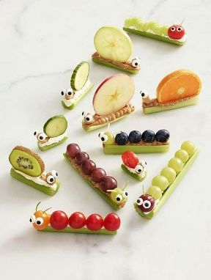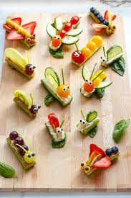  - Butterfly cakes:  https://www.bbcgoodfood.com/recipes/butterfly-cakes  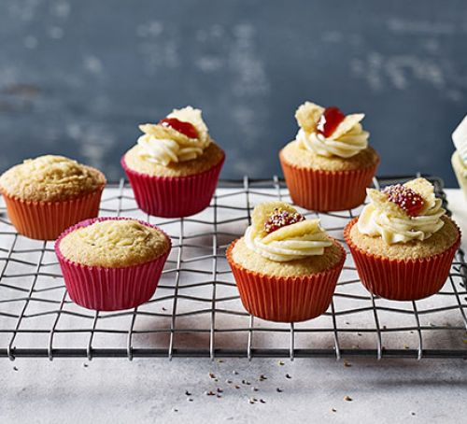  - Fruit Salad  https://www.bbcgoodfood.com/recipes/fruit-salad  

