Minibeasts - Activities

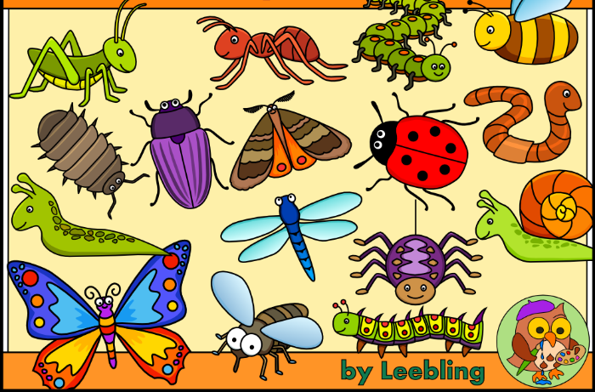
Choose any number of activities from the table below to do with your child over the course of the week.
Literacy Activities | - Listen to Superworm by Julia Daonaldson:  https://www.youtube.com/watch?v=7Jnk3XApKBg  - Write a description of a minibeast (use minibeast description sheet if you want)  - Have a go at reading the minibeast simple sentence cards  - Have a go at writing simple sentences about minibeasts, using a wordbank to help  - Use information books or the internet to research your favourite minibeast. Write a fact file about it.  - Do you have any stories about minibeasts? Share a story with your parents.
Creative ideas | - Paper plate bee or ladybird:  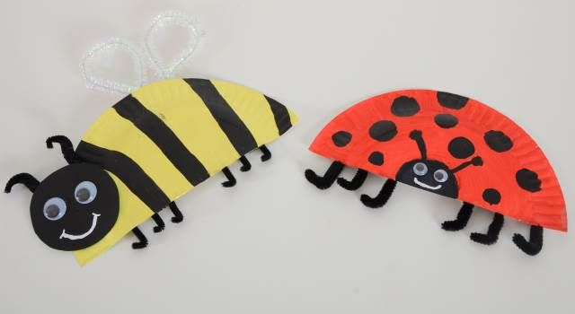  - Minibeast pebbles:  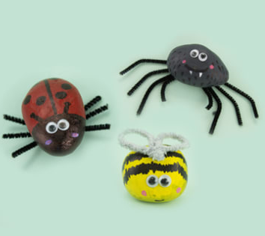  - Fingerprint snails:  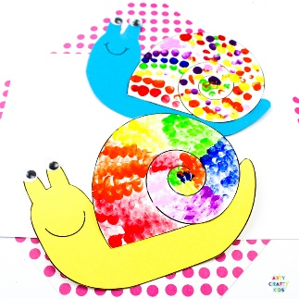
Science Activities | - Go on a minibeast hunt. Where do you think you might find some minibeasts? Draw a picture or take a photo of any you find. Remember to leave the creatures where you found them.  - Have a go at the Minibeast sorting activity
Sing some songs | - Incy Wincy Spider  https://www.bbc.co.uk/teach/school-radio/nursery-rhymes-incy-wincy-spider/zr4yt39  - Wiggly Woo  https://www.bbc.co.uk/teach/school-radio/nursery-rhymes-wiggly-woo/zvj8gwx  - Five Little speckled frogs  https://www.bbc.co.uk/teach/school-radio/nursery-rhymes-five-little-speckled-frogs/zjjbnrd

