James I & VI
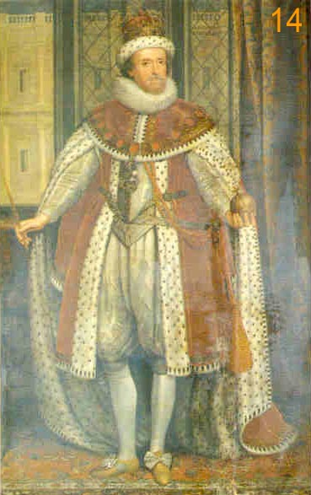
Elizabeth I had no children. Instead, she chose her cousin, James VI of Scotland to be her heir. He was already a King so knew what was required. Most importantly he was also Protestant and she wanted someone to continue her faith. She also hoped that by uniting Scotland and England under one King, it would prevent more wars between the two counties happening. Peace would prevail. The fact that he was her cousin also meant her family would remain ruling. Although he was family, his surname was Stuart. The Tudor dynasty had ended and the Stuart one began.
James I was very intelligent and could speak Latin, French and Italian. In an argument, James always stood by his point of view and could argue it well. The English councillors were impressed by James’ ability to make quick decisions, but alarmed by his rather unusual manners. James was a clever man. He tried to keep everybody happy with his decisions and not annoy anyone. While most of the world was at war, he kept his country in peace.
James was loyal to his friends and often gave them important jobs. Other people may have seen this as favouritism, not loyalty. James I believed that he was sent from God to be King - the Divine Right of Kings so he only had a responsibility to God and nobody else. This meant he did not always take the advice of his parliament or ministers.
James was extravagant and his advisers struggled to make him spend less. Some people disliked the fact that he had favourites who he showered with gifts and gave important jobs that they may not have been able to do well.
James had been brought up Protestant, but his mother Mary, Queen of Scots had been Catholic. At first, James stopped Catholics from having to pay fines for not going to Protestant church services. Most English people were suspicious of Catholics, so people objected to James being soft on them. James was a Scottish king on an English throne – he needed to win the support of the English Protestants who made up most of the population, so eventually James was persuaded to bring back the fines. A crackdown began on those refusing to attend Protestant churches, leading to over 5,000 Catholics being convicted. This also raised some very welcome money.
There is debate about the Gunpowder Plot – were the Catholics trying to overthrow James or were James’ own advisors trying to make him believe the Catholics were plotting against him and parliament so that he wouldn’t be so soft on them?

