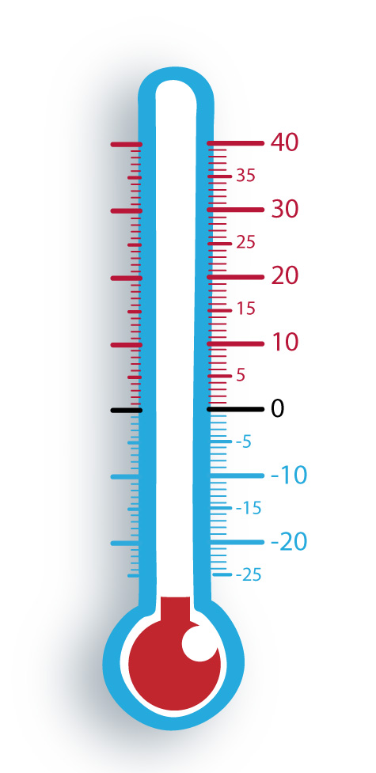
What’s hot and what’s not about James I?
NOT HOT
HOT

