Summer - Activities

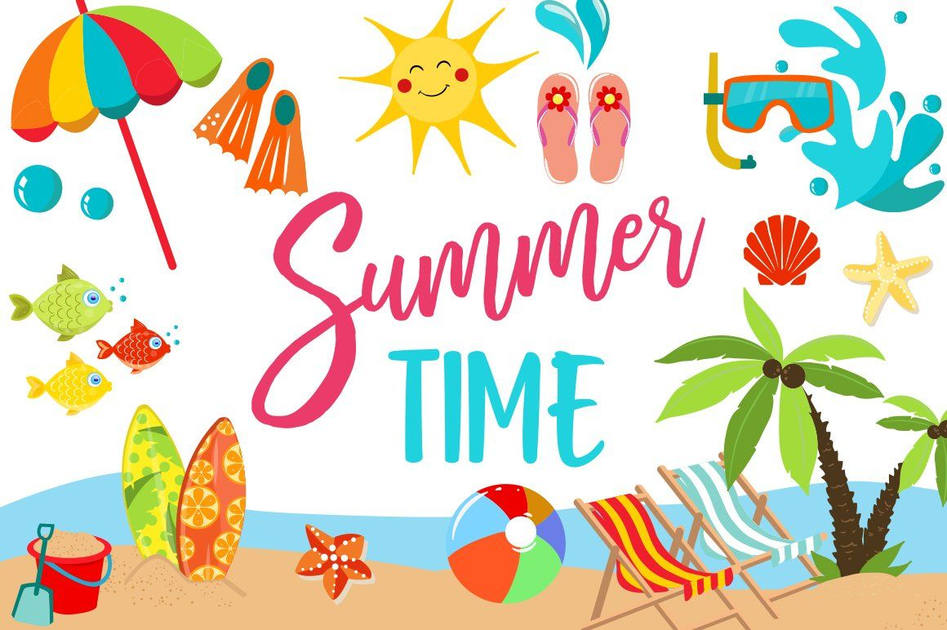
Choose any number of activities from the table below to do with your child over the course of the week.
Literacy Activities | - Listen to Lucy and Tom at the Seaside by Shirley Hughes:  https://www.youtube.com/watch?v=TOH5JDep6Pk  - Write about the different things you might see in the summer (In the Summer writing frame)  - Make a list of the clothes you wear in the summer and the clothes you wear in the winter.  - Summer read and colour – can you read the sentences to find out which colours you need for each picture.  - Write about your hopes for the summer (Summer Holiday Hopes)  - Write a postcard to someone telling them about a holiday you’ve been on.
Creative ideas | - Make a paper pinwheel:  https://www.instructables.com/id/Pinwheel/  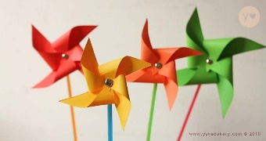  - Make your own ice creams or lollipops  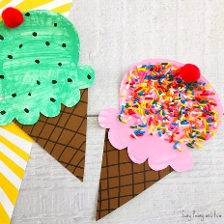 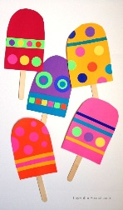#
Science Activities | - 2 coloured Daisy Experiment  - Walking Rainbow Investigation  - Rainbow Jar Activity  As always, these activities need quite specific resources that you might or might not have, so don’t worry if you don’t manage to do them.
Sing some songs | - The sun has got his hat on:  https://www.youtube.com/watch?v=TTZcADVbTuc  - I do like to be besides the seaside:  https://www.youtube.com/watch?v=kcHyyuGjuk0  - Summer Holiday  https://www.youtube.com/watch?v=SxuapKdqIZw  - Under the Sea  https://www.youtube.com/watch?v=Fkusy4ylhiY&t=46s
Cooking ideas

