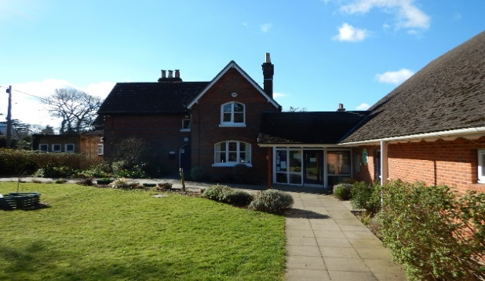
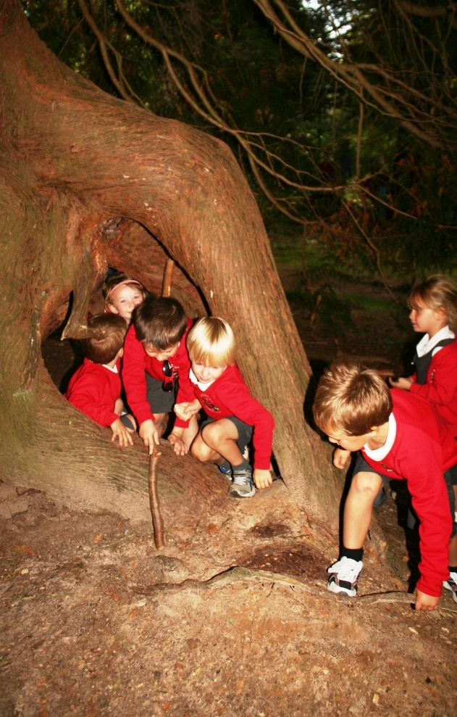
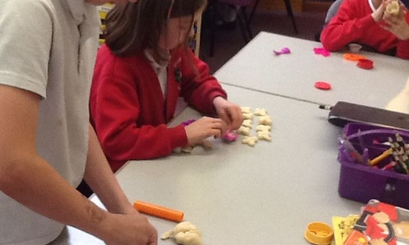

L
Loving, Hopeful and Thankful
Parent Information for Year 5
Teacher: Mrs Edwards/Miss Lever
TAs: Mrs Cowell
Homework
Homework will be set weekly. To be completed by the following week.
The following homework will be set:
- Reading (every day)
- Times Tables Rockstars (ongoing)
- Mathletics (Friday)
- Spelling Shed (Wednesday)

The Blog
Each year group has a blog on the school’s website. Teachers will regularly update it with information on the learning that has taken place and important information pertaining to the class.
You can sign up for push notifications to inform you every time a new blog has been published.

Class Routines
- Bring in named water bottle daily
- PE kit in daily
- Library book change weekly
Snacks
In KS2 children are allowed to bring a healthy snack to eat during break. The snack must be NUT FREE.
Brockenhurst C of E
Primary School
“We Enjoy and Excel In the
Presence of God”

National Curriculum
The programmes of study for Year 5 are set out in detail through the attached links.
www.primarycurriculum.me.uk/year5

The class long term map will be available on the website.

