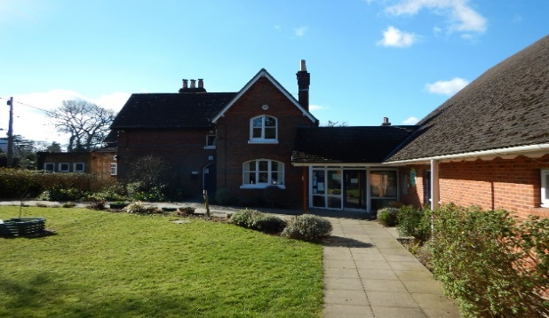
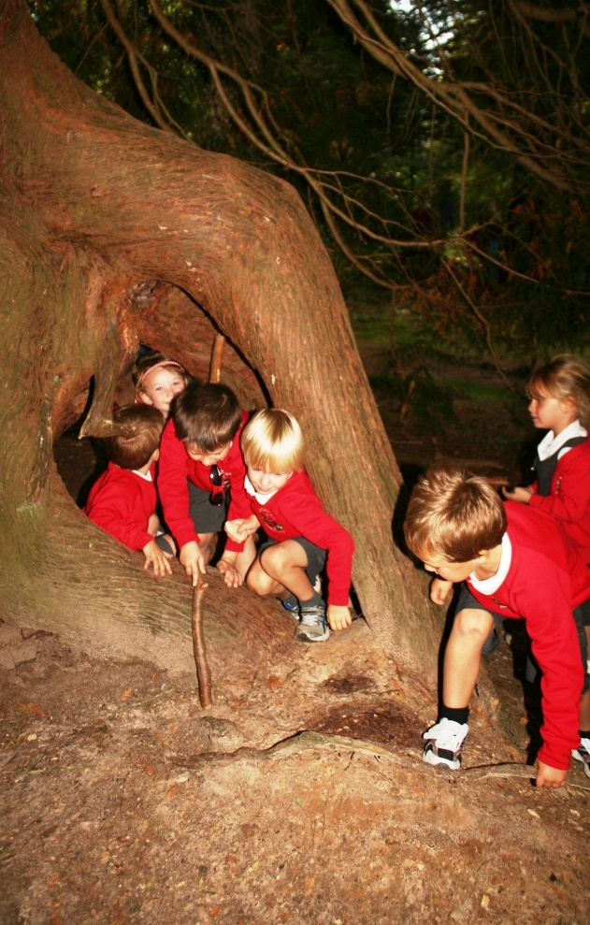
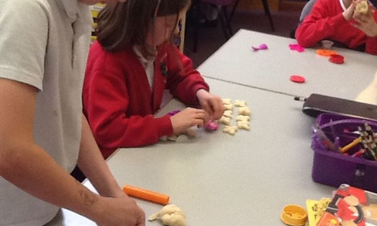

L
Loving, Hopeful and Thankful
Parent Information for Year 3
Teacher: Mr Wilcox, Mrs Lever
HLTA: Mrs Dunne, Mrs Cowell, Mrs Jones
Learning Mentor: Mrs Young

Homework
Homework will be set on a Wednesday each week to be in the following Tuesday.
The following homework will be set:
- Reading (every day)
- Times tables
- Mathletics
- Spellings
- SPAG

The Blog
Each year group has a blog on the school’s website. Teachers will regularly update it with information on the learning that has taken place and important information pertaining to the class.
You can sign up for push notifications to inform you every time a new blog has been published.

Class Routines
- Bring in water bottle daily
- PE kit in daily
- Book change – available every day to the children when they come in.
Snacks
Children are allowed to bring or purchase a healthy snack to eat during break. The snack must be NUT FREE.
Brockenhurst C of E
Primary School
“We Enjoy and Excel In the
Presence of God”

National Curriculum
The programmes of study for Year 3 are set out in detail through the attached links.
http://www.primarycurriculum.me.uk/year3
Each half term a curriculum map will be uploaded on the blog detailing the learning for that half term.

