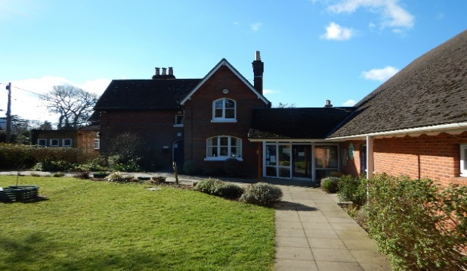
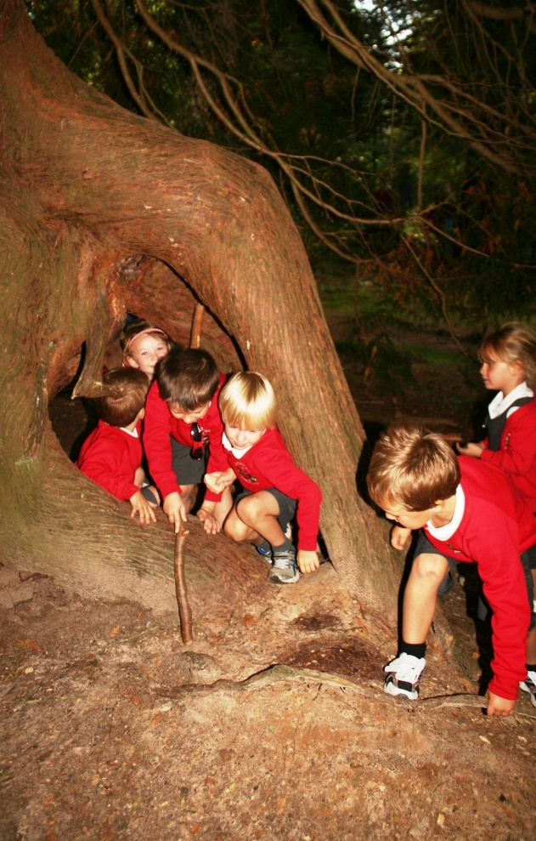
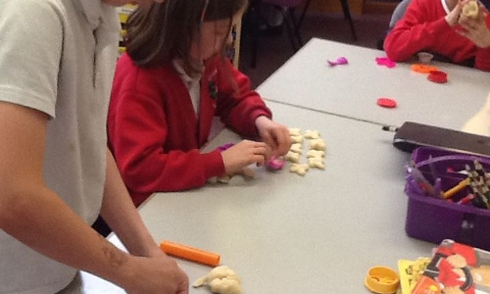

L
Parent Information for Year 1
Teacher: Miss McKay
TA: Mrs Cooper

Loving, Hopeful and Thankful
Homework
Homework will be set on a Wednesday each week, to be completed by the following Wednesday.
The following homework will be set:
- Reading and key words (every day)
- Number fluency
- Mathletics
- Spellings (Spelling Shed)

The Blog
Each year group has a blog on the school’s website. Teachers will regularly update it with information on the learning that has taken place and important information pertaining to the class.
You can sign up for push notifications to inform you every time a new blog has been published.

Class Routines
- Bring in water bottle daily
- PE kit in daily
- Book change
Snacks
In reception and KS1 children receive a piece of free fruit at first break. Children are allowed to bring or purchase a healthy snack to eat during break. The snack must be NUT FREE.
Brockenhurst C of E
Primary School
“We Enjoy and Excel In the
Presence of God”

National Curriculum
The programmes of study for Year 1 are set out in detail through the attached links.
http://www.primarycurriculum.me.uk/year1
The class long term map will be available on the school website.

