Parent guidance
Click 'File', then 'Export':

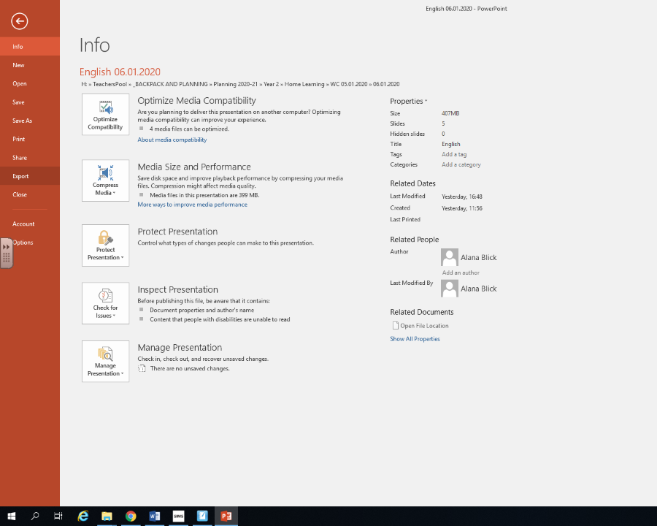

Then click create a video and select 'Internet Quality'. Then click create video.

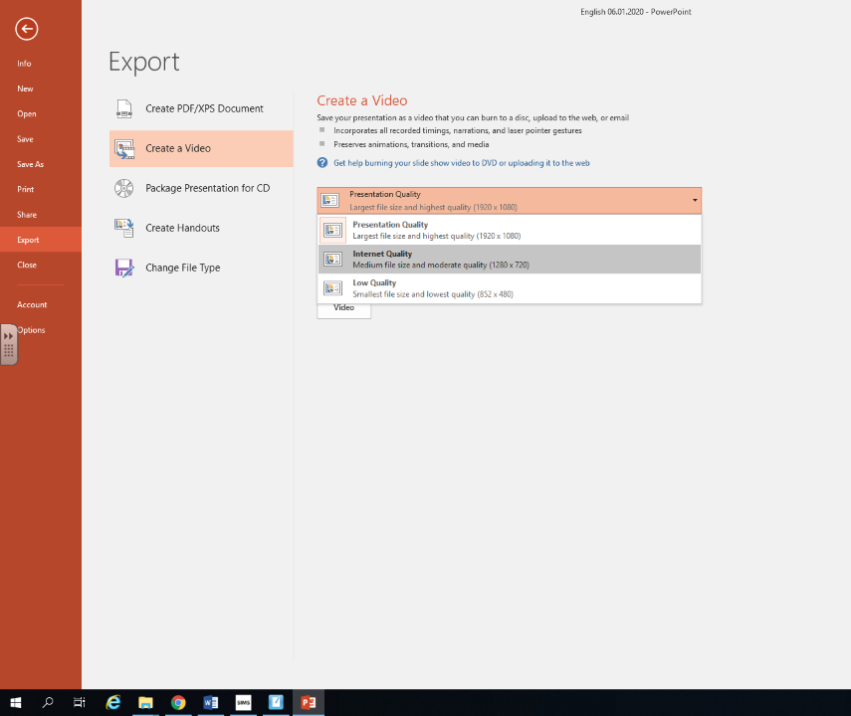
This then converts the PowerPoint into a video.

