Year R Badger Class – Wellbeing Wednesday
Wednesday 3rd March
Make a sandwich – use your plan from yesterday to make a delicious sandwich  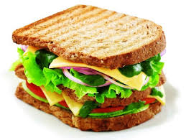 | Try another recipe from Mr Wolf and the Three Bears  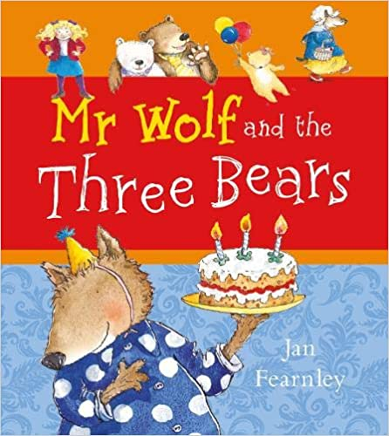 | Go on a Colour  Scavenger Hunt  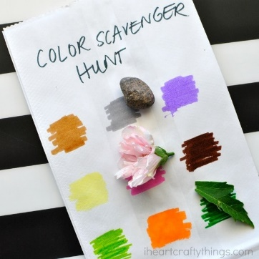
World Book Day  Scavenger Hunt   |   Wellbeing Wednesday | Be a sandwich artist  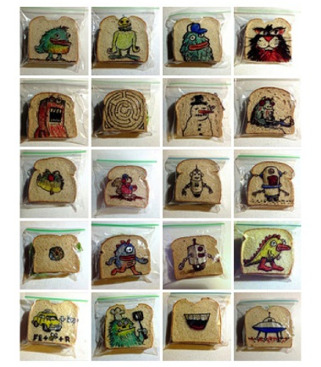
Make a number book – choose a number or do every number from 1-10  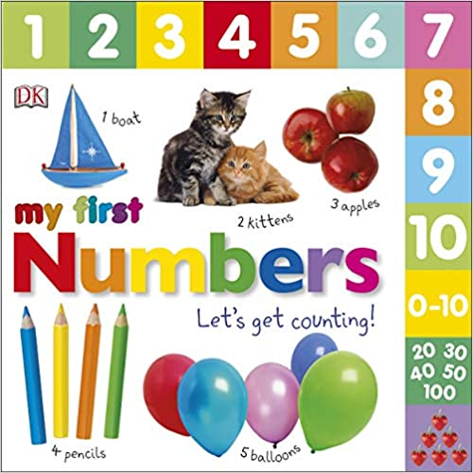 | Cosmic Yoga with Jaime – Safeguard the Handwashing Soap   | What Lives on Us – Science Experiment
https://www.youtube.com/watch?v=5rymXdOwW68&list=PL8snGkhBF7nhEquR7wXbzIXjFrlXsze_H&index=19&t=18s

