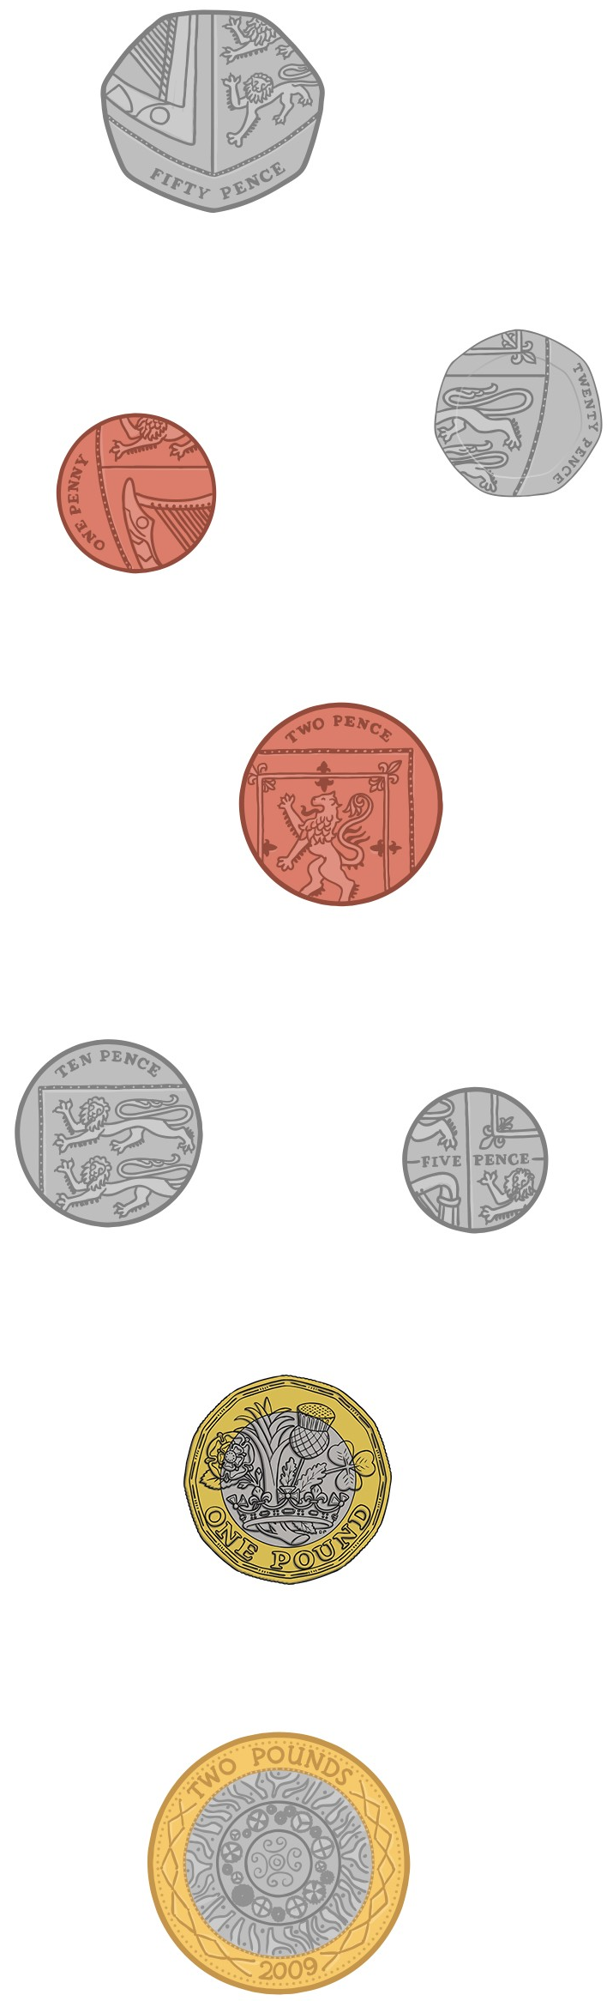
£2
£1
20p
50p
10p
5p
2p
1p
Cut and stick the coins in the right place.
Coin Recognition

