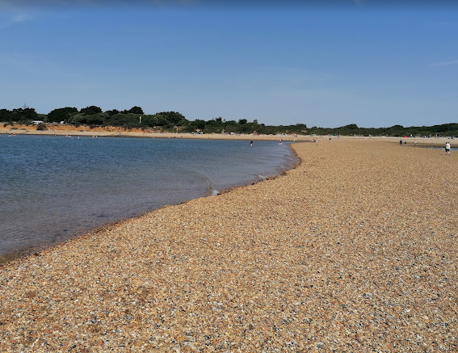
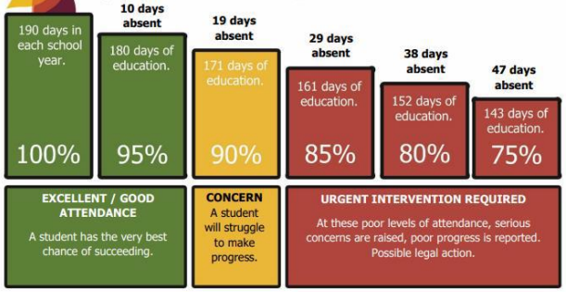
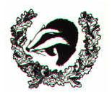
L
The Blog
Each year group has a blog on the school’s website. Teachers will regularly update it with information on the learning that has taken place and important information pertaining to the class.
You can sign up for push notifications to inform you every time a new blog has been published.
https://www.brockenhurstceprimary.co.uk/blog/?pid=8&nid=4
Homework
Homework will be set (through Ed Shed) on a Friday, to be completed by the following Friday. All usernames and passwords can be found in your child’s reading record.
In Year 1 it is expected that children will:
Reading
- Little Wandle- read once a week
- School reading book – read daily
- Practise their Number fluency cards
- Edshed Maths
Class Routines
The gates open at 8.25am and there is morning work ready for the class to complete. Year 1’s school day finishes at 3:10pm.
- Bring in water bottle daily
- PE kit in daily
- Book change weekly
- Library change weekly
Details about our uniform can be found here: https://www.brockenhurstceprimary.co.uk/page/?title=Uniform%26%23160%3B&pid=45
Snacks In Reception and KS1 children receive a piece of free fruit and milk at first break, (the milk is free in Reception). In KS2 children are allowed to bring or purchase a healthy snack to eat during break. The snack must be NUT FREE.

Ambitious, Independent, Resilient, Resourceful, Inclusive, Caring
Parent Information for Year 1
2024-2025
Teachers: Miss Lever (Monday)
Mrs Platt (Tuesday- Friday)
TA: Mrs Kitcher
Loving, Hopeful and Thankful

National Curriculum
The programmes of study for Year 1 are set out in detail through the attached links.
https://assets.publishing.service.gov.uk/government/uploads/system/uploads/attachment_data/file/425601/PRIMARY_national_curriculum.pdf
More information on our curriculum can be found on our school website.
https://www.brockenhurstceprimary.co.uk/page/?title=Curriculum&pid=75

Brockenhurst C of E
Primary and Pre-School
“We Enjoy and Excel In the
Presence of God”

