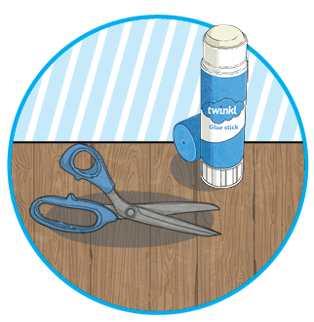
You Will Need:
Cut out the shapes below and stick them back to back. Whilst reading with your child, try to choose one question from each section. You could ask more than one type of question per page. This will check that your child really understands what they are reading and could lead you into further conversations about the book.

Questions for Reading Bookmark

Be an Author
- What does the word... tell you about...? How?
- Find two ways that the author tells you...

Summarising Questions
- What is the main point in this paragraph? Is it mentioned anywhere else?
- Sum up what has happened so far in… words/seconds or less.
- Which is the most important point in these paragraphs? Why?
- Do any sections/paragraphs deal with the same themes?

Retrieval Questions
- Find the... in this text. Is it anywhere else?
- When/where is this story set? Find evidence in the text.
- Find the part of the story that best describes the setting.
- What do you think is happening here? Why?
- Who is telling this story?
Vocabulary Questions
- What does this word/phrase/sentence tell you about the character/setting/mood?
- By writing..., what effect has the author created? Do you think they intended to?
- What other words/phrases could the author have used here? Why?
- How has the author
made you/this character feel
by writing...? Why?

Inference Questions
- What do you think… means? Why do you think that? Could it be anything else?
- I think...; do you agree? Why/why not?
- Why do you think the author decided to…?
- Can you explain why…?
- What do these words mean
and why do you think that
the author chose them?
- Which words do you think are most important? Why?
- Which words do you like the most? Why?
- How has the author made you feel happy/sad/angry/frustrated?
- What do you think the author meant by…?
Compare, Contrast and Comment
- What is similar/different about two characters? Did the author intend that?
- Explain why... did that.
- Describe different characters’ reactions to the same event.
- Does this story have a moral?
- Which is better and why?
Prediction Questions
- Can you think of another story with a similar theme? How do their plots differ?
- Which stories have openings like this? Do you think that this story
will develop the same way?
- Why did the author choose this setting? Will that influence the story?

