Year | Term | Theme | Artist/ Craftperson/ Designer | Art Elements |  | Techniques
Year R | Autumn 1 | 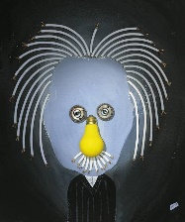  All about me  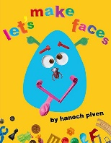 | Hanoch Piven (Artist, author and illustrator) | Drawing  Painting  Collage  Sculpture (transient art) |  | Colour  Pattern  Texture  Line  Shape  Form  Space
Year R |  | Vehicles  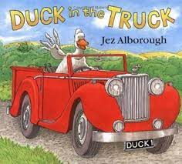 |  | Drawing – half pictures to complete  Painting  Sculpture – junk modelling |  | Colour  Pattern  Texture  Line  Shape  Form  Space
Year R | Autumn 2 | Fruit and Veg  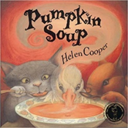 |  | Drawing – observational drawing  Painting  Printing |  | Colour  Pattern  Texture  Line  Shape  Form  Space
Year R |  | Christmas |  | Drawing  Painting  Printing – fingerprint pictures/ cork printing |  | Colour  Pattern  Texture  Line  Shape  Form  Space
Year R | Spring 1 | Goldilocks  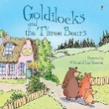 |  | Drawing - favourite story character  Painting  ? |  | Colour  Pattern  Texture  Line  Shape  Form  Space
Year R |  | Chinese New Year   | Traditional | Drawing  Painting  Collage - lanterns |  | Colour  Pattern  Texture  Line  Shape  Form  Space
Year R | Spring 2 | Animals  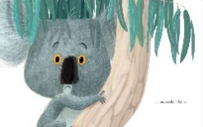 | Jim Field – illustrator | Drawing  https://www.jimfield.me/draw  Painting  Collage  Printing  Sculpture – air dry clay models |  | Colour  Pattern  Texture  Line  Shape  Form  Space
Year R |  | Plants  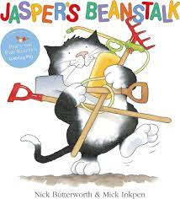 |  | Drawing  Painting  Sculpture – pipe cleaner linear sculptures  Textiles - flowers |  | Colour  Pattern  Texture  Line  Shape  Form  Space
Year R | Summer 1 | 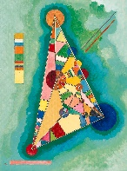  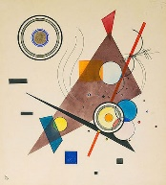  Circles and triangles | Wassily Kandinsky | Drawing (stencil shapes)  Painting  Collage (different papers – coloured paper & card/ tissue paper etc.) |  | Colour  Pattern  Texture  Line  Shape  Form  Space
Year R |  | Dragons  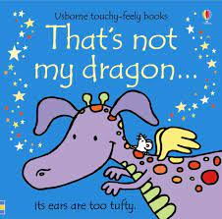 |  | Drawing  Painting  Textiles – make dragon with different textures |  | Colour  Pattern  Texture  Line  Shape  Form  Space
Year R | Summer 2 | 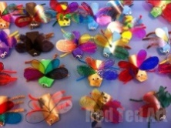  Minibeasts  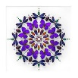 | Christopher Marley |  | Drawing  Painting  Collage & Textiles  Sculpture - transient art, Minibeast pebbles  https://www.redtedart.com/cardboard-tube-minibeasts/ | Colour  Pattern  Texture  Line  Shape  Form  Space
Year R | Summer 2 | 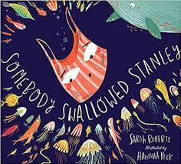  Recycling |  |  | Drawing  Painting  Printing  Collage  Sculpture – junk modelling | Colour  Pattern  Texture  Line  Shape  Form  Space

Year 1 | Autumn 1 | 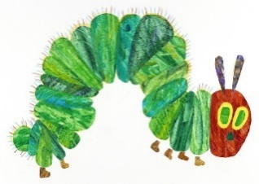  Nature Art | Eric Carle | Drawing  Painting  Collage  Sculpture | Colour  Pattern  Texture  Line  Shape  Form  Space
Year 1 | Autumn 2 | Angels  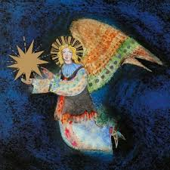 | Brian Wildsmith (National Gallery) | Drawing  Painting  Collage  Sculpture (pipe cleaners and tissue)  Art and ICT (Photographs) | Colour  Pattern  Texture  Line  Shape  Form  Space
Year 1 | Spring 1 | Animals  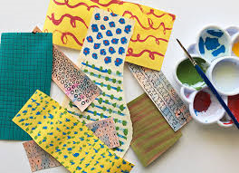  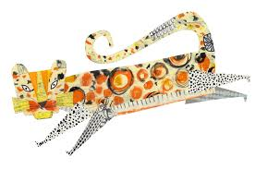 | Clare Youngs  https://www.clareyoungs.co.uk  Illustrator - Eric Carle | Drawing  Painting  Collage  Printing (block)  Sculpture – card and split pin/ dowel  Art and ICT- photograph/ chatterpix | Colour  Pattern  Texture  Line  Shape  Form  Space
Year 1 | Spring 2 | 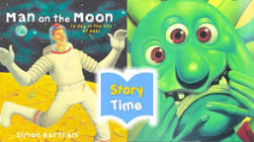  Dear Moon  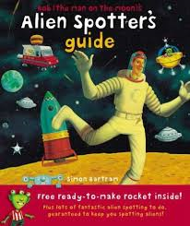 | Simon Bartram – Illustrator  Oliver Jeffers? | Drawing  Painting  Collage  Sculpture (papier mache- and malleable aliens)  Art and ICT (photography) | Colour  Pattern  Texture  Line  Shape  Form  Space
Year 1 | Summer 1 | 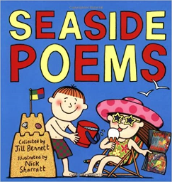  Seaside | Nick Sharratt - illustrator | Drawing  Painting  Textiles  Sculpture  Art and ICT (photograph/ selfie) | Colour  Pattern  Texture  Line  Shape  Form  Space
Year 1 | Summer 2 | 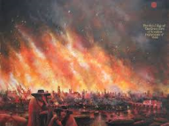  Great Fire of London  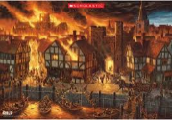 | Various Traditional | Drawing  Painting  Collage  Sculpture  Art and ICT(photography) | Colour  Pattern  Texture  Line  Shape  Form  Space

Year 2 | Autumn 1 | Frozen  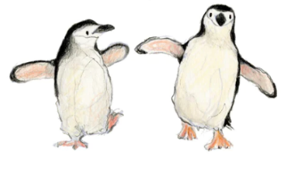 | Catherine Rayner | Drawing  Painting  Collage  Sculpture | Colour  Pattern  Texture  Line  Shape  Form  Space
Year 2 | Autumn 2 | Titanic Hats  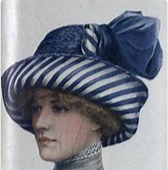 | Traditional | Drawing  Painting  Sculpture | Colour  Pattern  Texture  Line  Shape  Form  Space
Year 2 | Spring 1 | Rwanda  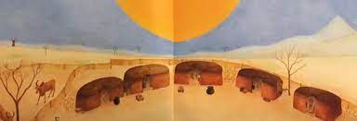 | Jude Daly - illustrator | Drawing  Painting/colour mixing Collage - Mountain/skyline collage – inspired by illustrations of English text: ‘Lila and the Secret Of The Rain’.  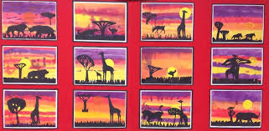 | Colour  Pattern  Texture  Line  Shape  Form  Space
Year 2 | Spring 2 | Easter Eggs  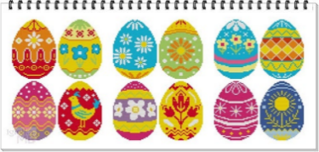  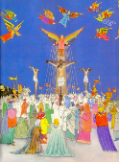 | Brian Wildsmith – illustrator  Polish folk art and contemporary egg designers  Fabergé | Drawing  Painting  Sculpture (malleable/ eggs (wooden/polystyrene))  Art and ICT (photographs) | Colour  Pattern  Texture  Line  Shape  Form  Space
Year 2 | Summer 1 | 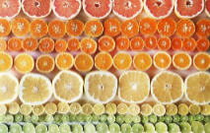  Tutti Frutti  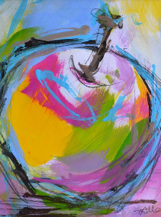  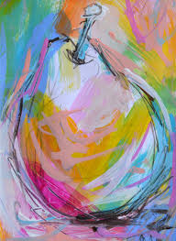 | Rudibrulz  Brittany Wright | Drawing (pencil/ charcoal)  Painting (poster/ pastles)  Collage (Surface for printing – tissue)  Printing (Poly block)  Textiles  Sculpture  Art and ICT (Photographs) | Colour  Pattern  Texture  Line  Shape  Form  Space
Year 2 | Summer 2 | Floral Delight  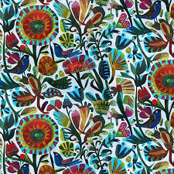  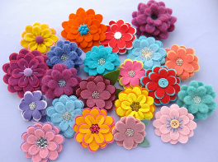 | Este Macleod  Laura Howard | Drawing (pencils/ pens)  Painting (Watercolours)  Textiles (Felt, cut, stick and stitch)  Art and ICT | Colour  Pattern  Texture  Line  Shape  Form  Space

Year 3 | Autumn 1 | Stone Age  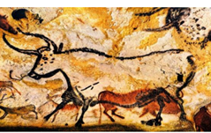  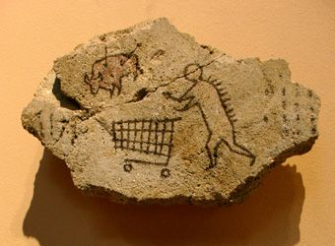 | Lascaux Caves  Satoshi Kitamura | Drawing (Charcoal/ pens)  Painting (washes, drawing in brown paint)  Sculpture (construction- mod roc)  Art and ICT (photography) | Colour  Pattern  Texture  Line  Shape  Form  Space
Year 3 | Autumn 2 | Coming Home  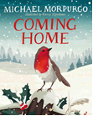 | Kerry Hyndman – illustrator  Monoprint artist? | Drawing (pastel monoprinting and pencil)  Painting Washes and resist  Printing (monoprint)  Sculpture (Malleable)  Art and ICT | Colour  Pattern  Texture  Line  Shape  Form  Space
Year 3 | Spring 1 | Megacities  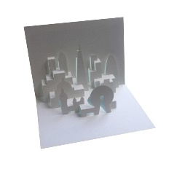  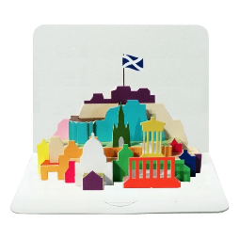 | Elod Beregszaszi  http://www.popupology.co.uk | Drawing  Painting  Collage  Sculpture (card construction)  Art and ICT (photography) | Colour  Pattern  Texture  Line  Shape  Form  Space
Year 3 | Spring 2 | Plants and seeds  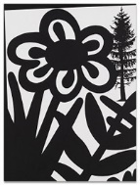  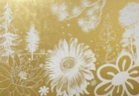  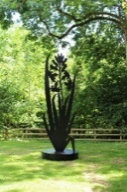 | Paul Morrison | Drawing (white gel pens, fine liners, ink)  Printing (mono – cut outs)  Collage  Sculpture  Art and ICT | Colour  Pattern  Texture  Line  Shape  Form  Space
Year 3 | Summer 1 | Iron Man  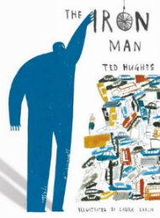  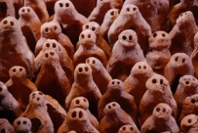 | Laura Carlin – illustrator  Anthony Gormley  Henry Matisse | Drawing (pencils)  Painting ( powder)  Collage (cut- out)  Sculpture (clay)  Art and ICT (photography) | Colour  Pattern  Texture  Line  Shape  Form  Space
Year 3 | Summer 2 | Sustainability  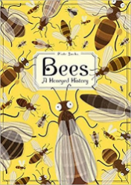  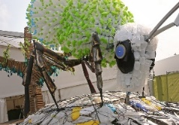 | Piotr Socha – illustrator  Ptolemy Elrington | Drawing (pencil)  Painting (watercolour/ powder)  Collage  Sculpture (scrunched paper bees/ recycled bottles)  Art and ICT (photography) | Colour  Pattern  Texture  Line  Shape  Form  Space

Year 4 | Autumn 1/ Autumn 2 | Nature Trail  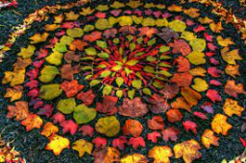 | Andy Goldsworthy  Georgia O’Keeffe  Rebecca Stanton  Lubov Pavluk  artisam.cam.org.uk ? | Drawing (Obs-pencil, pens)  Painting - Mixing  Sculpture (land art)  Art and ICT (photographs) | Colour  Pattern  Texture  Line  Shape  Form  Space
Year 4 | Spring 1 | Polar Express  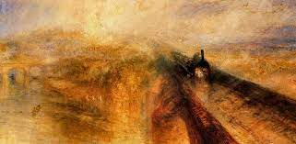 | JMW Turner  Polar Express Film  Chris Van Allsburg  National Gallery  Tate Britain | Drawing (perspective- pencil and pens)  Painting  Collage (ticket)  Art and ICT (photograph) | Colour  Pattern  Texture  Line  Shape  Form  Space
Year 4 | Spring 2 | All That Glitters!  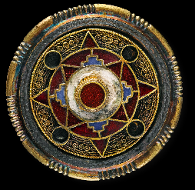 | Anglo Saxon Jewellery designs  British Museum  V&A Museum  ‘All that Glitters’ designers | Drawing  Painting  Collage  Sculpture  Art and ICT | Colour  Pattern  Texture  Line  Shape  Form  Space
Year 4 | Summer 1 | Treehouses  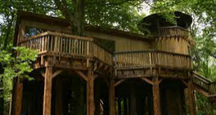 | Samantha Sherwood  Frank Lloyd Wright  Ludwig Mies Van Der Rhoe  Emily Hughes  Royal Academy Show | Drawing  Painting  Collage  Printing (Card)  Sculpture  Art and ICT (photography) | Colour  Pattern  Texture  Line  Shape  Form  Space
Year 4 | Summer 2 | Dragons  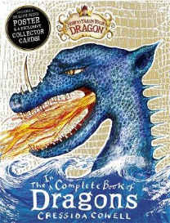  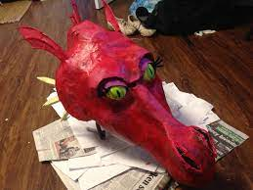 | Cressida Cowell  Mark Robertson  Helen ward/ Wayne Anderson and AJ Wood (Dragonology)  Traditional | Drawing (pencil, pastel, chalk, pen)  Painting (poster)  Collage  Printing (block)  Sculpture  Art & ICT (Minecraft) | Colour  Pattern  Texture  Line  Shape  Form  Space

Year 5 | Autumn 1/Autumn 2 | 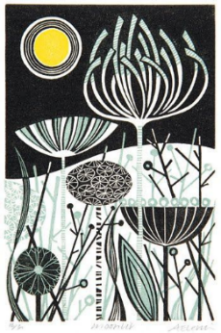  The Outside World  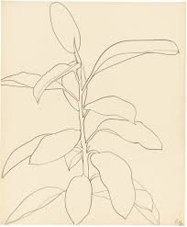 | Ellsworth Kelly  Angie Lewin | Drawing (pencil/ pen)  Painting (Watercolour)  Printing (monoprint/press print)  Textiles Batik  Art and ICT (photography) | Colour  Pattern  Texture  Line  Shape  Form  Space
Year 5 | Spring 1 | Shaun Tang – Singing Bones  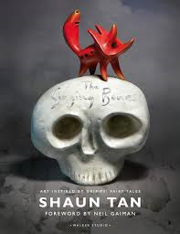 | Shaun Tan | Drawing  Painting  Sculpture (Clay/ air dough)  Art and ICT (photography) | Colour  Pattern  Texture  Line  Shape  Form  Space
Year 5 | Spring 2 | The Empire: British Art  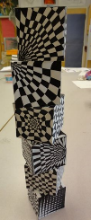 | Bridget Riley  Union Jack Artists | Drawing  Painting  Collage  Printing  Textiles  Sculpture  Art and ICT(Photography) | Colour  Pattern  Texture  Line  Shape  Form  Space
Year 5 | Summer 1 | 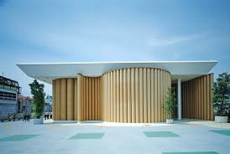  Outdoor World  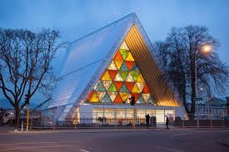 | Shigeru Ban - architect | Drawing  Painting  Sculpture  Art and ICT (photography) | Colour  Pattern  Texture  Line  Shape  Form  Space
Year 5 | Summer 2 | Brockenhurst Railway  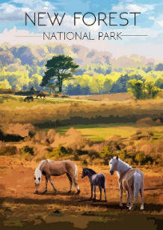 | Vernie L Danvers  London Transport Artists | Drawing  Painting  Collage  Printing  Art and ICT (photography) | Colour  Pattern  Texture  Line  Shape  Form  Space

Year 6 | Autumn 1 | Landscapes – link to Swanage residential  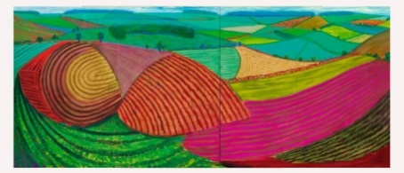 | David Hockney  Local Swanage artists:  Paul Longland  Charles Condor  Oliver Pyle | Drawing  Painting  Collage  Photography | Colour  Pattern  Texture  Line  Shape  Form  Space
Year 6 | Autumn 2 | Climate Change  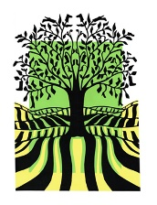  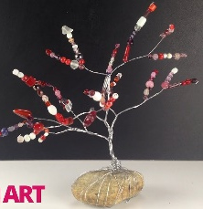 | Vanessa Stone  Johanna Basford  Millie Marotta  Kristjana Williams | Painting  Collage  Sculpture | Colour  Pattern  Texture  Line  Shape  Form  Space
Year 6 | Spring 1 | 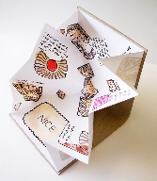  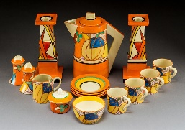  Art Deco inspired Sandwich Sketchbook | Ruth Martin  Clarice Cliff | Drawing  Painting  Printing | Colour  Pattern  Texture  Line  Shape  Form  Space
Year 6 | Spring 2 | 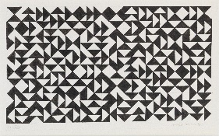  Annie Albers: The work of a Craftsmaker  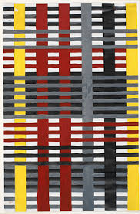  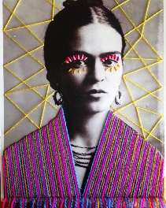 | Anni Albers  Victoria Villasana. | Drawing  Painting  Collage  Textiles | Colour  Pattern  Texture  Line  Shape  Form  Space
Year 6 | Summer 1 | Starry Night  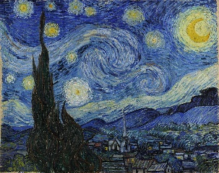 | Vincent Van Gogh | Drawing  Painting | Colour  Pattern  Texture  Line  Shape  Form  Space
Year 6 | Summer 2 | American Artist  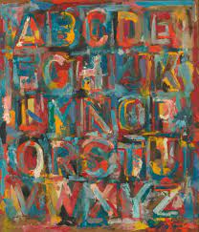 | Jasper Johns | Drawing  Painting  Collage  Sculpture  Photography | Colour  Pattern  Texture  Line  Shape  Form  Space

