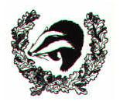
L
Homework
Homework will be set on a Friday (through Ed Shed) each week to be completed by the following Friday.
In Year 5 it is expected that children will:
- Read (every day)
- Practise times tables
- Maths challenge (Ed Shed)
- Spelling challenge (Ed Shed)

Brockenhurst C of E
Primary and Pre-School

Class Routines
The gates open at 8.25am and there is morning work ready for the class to complete. Year 5 finishes at 3.15pm.
- Bring in water bottle daily
- PE kit in daily
- Book change - Monday
- Library change - Monday
Details about our uniform can be found here: https://www.brockenhurstceprimary.co.uk/page/?title=Uniform%26%23160%3B&pid=45
Snacks
In KS2 children are allowed to bring or purchase a healthy snack to eat during break. The snack must be NUT FREE.

“We Enjoy and Excel In the
Presence of God”

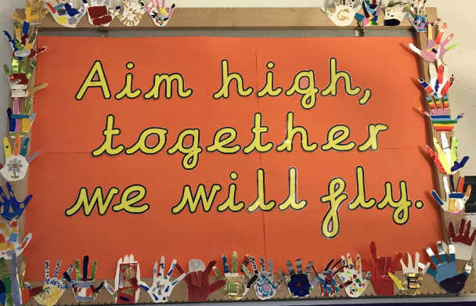
Loving, Hopeful and Thankful

Parent Information for Year 5
Teacher: Mrs Edwards and Mrs Erdbeer
TA: Georgina Cowell

The Blog
Each year group has a blog on the school’s website. Teachers will regularly update it with information on the learning that has taken place and important information pertaining to the class.
You can sign up for push notifications to inform you every time a new blog has been published.
https://www.brockenhurstceprimary.co.uk/page/?title=Classes&pid=8

National Curriculum
The programmes of study for Year 5 are set out in detail through the attached links.
https://www.gov.uk/government/collections/national-curriculum
More information on our curriculum can be found on our school website.
https://www.brockenhurstceprimary.co.uk/page/?title=Curriculum&pid=75

Ambitious, Independent, Resilient, Resourceful, Inclusive, Caring



