Ten Pegs on a Hanger

You need: number cards, 0 to 10 with two number 5s. Also, a metal coat hanger, ten clothes pegs and a tea-towel. (If you don’t have pegs, you can create the same effect by hanging paper clips or safety pins or even bracelets or hair ties from the coat hanger!)

How to play
- Lay out the number cards face up.

- Peg ten pegs along the coat-hanger. Count them along it, touching each one as you go. One, two, three, etc.

- Ask your child to turn around. Cover some of the pegs by hanging the tea-towel over it.

- The child must choose the number card to match the number of pegs hidden. They show you.

- Reveal the hidden pegs – were they correct?

- If so, they find the number card to match the pegs which were not hidden.
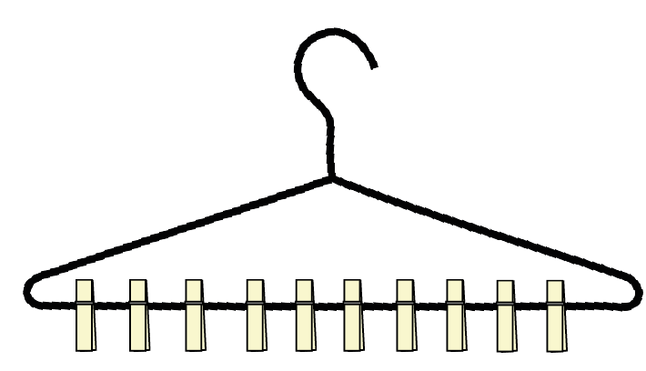
- Write a matching addition for these pegs, e.g. 6 + 4 = 10

- Now play again, with you hiding a different number of pegs.

- Keep playing like this, perhaps taking turns to hide the pegs.

