Year R Badger Class – Wellbeing Wednesday
Wednesday 24th February
Bouncy Egg Science Experiment  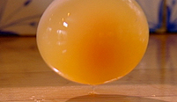 | Heavy or Light Chart – compare objects in your home and decide if they are heavy or light  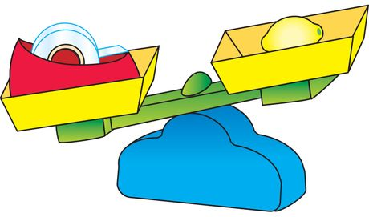 | Wednesday Recipe – make pancakes
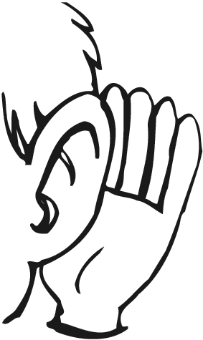  Go on a  Listening Walk | 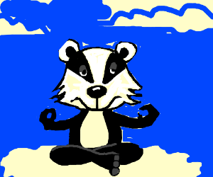  Wellness Wednesday | 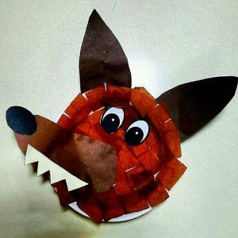  Paper Plate Wolf
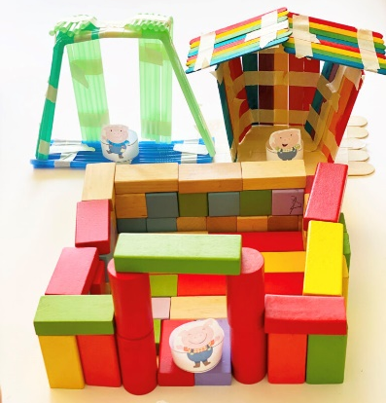  Build houses for  The 3 little pigs | Cosmic Yoga with Jaime – Tommy the Bedtime Turtle  https://www.youtube.com/watch?v=gCLW77sABTc  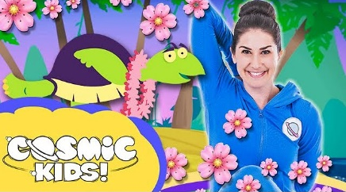 | Have fun with playdough!  