Subject | Timings | Activity
PE | 30 mins | Cricket Week 1 - https://www.chancetoshine.org/staying-active-during-the-covid-19-outbreak?utm_source=Portal+Teachers&utm_campaign=4d044a96ba-EMAIL_CAMPAIGN_2020_04_14_04_17&utm_medium=email&utm_term=0_b4486fc5f7-4d044a96ba-123743345#h_66039831311586267782474  Or  Joe Wicks Daily
Mental Maths | 5 minutes | 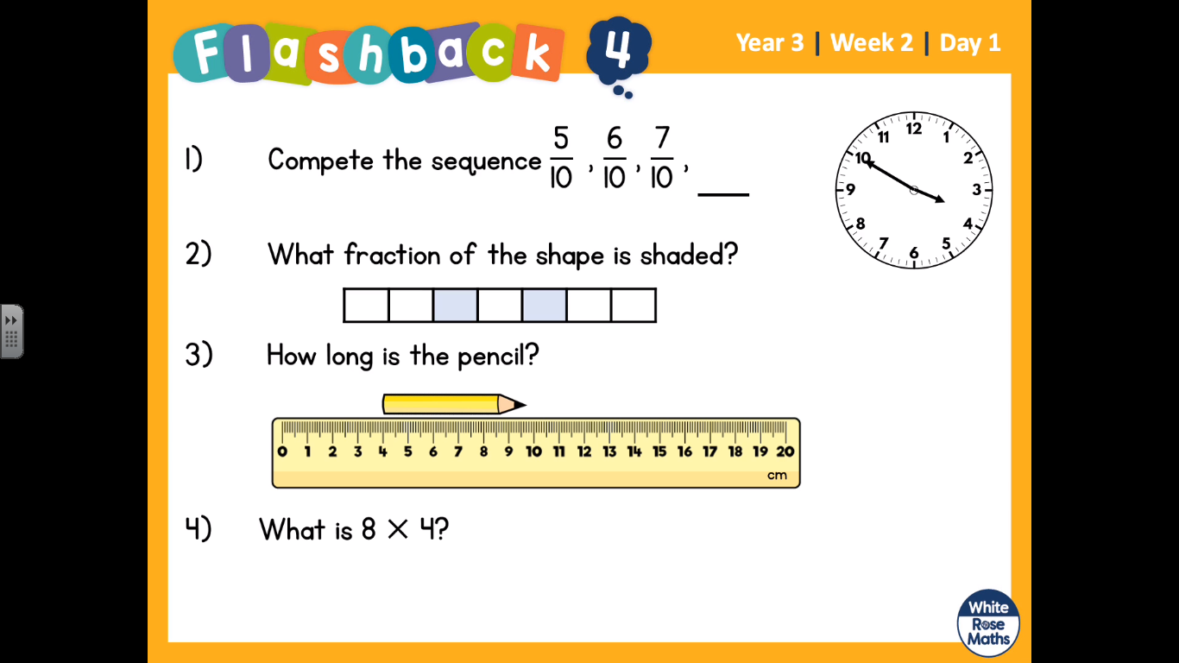  These questions are on the video on White Rose home learning week 2.
Maths | 45 minutes | LO: Work out fractions on a number line?  Steps to success:  Count the lines on the number line between 0-1. How many lines are there?  This is your bottom number of your fraction (denominator).  Where is the arrow pointing to, count along the number line this is your numerator (top part of the fraction).  https://whiterosemaths.com/homelearning/year-3/  Week 2 - whiterose home learning
Reading | 15 Minutes | https://www.lovereading4kids.co.uk/extract/11823/  This is a link to some short stories.  Read the Snake Prince to page 10. Write down any interesting/tricky words that you find and look them up in the dictionary.  https://kids.britannica.com/kids/browse/dictionary
Writing | 30 minutes | Lesson 1 – Visit the zoo!  LO: Describe what you see at the zoo  Visit the webcams at San Diego Zoo! https://kids.sandiegozoo.org/videos  Spend some time enjoying the animals and their habitats – remember that patience is required to spot animals at a zoo!  Discuss what can be seen and how to describe this for visitors.  If you would like to turn this into a game, describe what you can see in the zoo to somebody who can’t see it, they must draw what you describe. After 4 minutes, see what they have drawn (you can’t peek before). Think about words and phrases that help with descriptions e.g.  It looks like …  It is shaped like …  It is coloured like …  Describe the nouns; a rope swing, a big netting,
Spellings | 15 mins | Pictowords. This is a weekly task, do not try to complete all your spellings in one go. Just do 15 minutes. You need to find the meaning of each spelling, and draw a picture around the word to show the meaning. See the picture below. Here are your spellings: basically, frantically, dramatically, historically, nationally, emotionally, accidentally, automatically, traditionally, specifically
Topic | 1 hour | 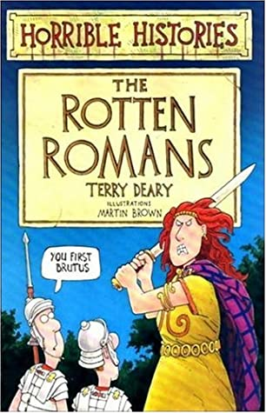  Create a colourful title page (A4) for our new topic, The Romans. It must include pictures and facts about the things that you already know about the Romans, it could include questions at the bottom of the page about things that you would like to find out.
Any free time check out our website for extra activities | N/A | https://sites.google.com/d/1AACR2Wo2mrXsLNCLpsrDG3ZY8ucn7msd/p/1K1uGSLLTaXnfArgCfsd4xPAQj5-cNh_Z/edit  There is a link to a lesson about astronomy on Wednesday at 10am.  WWF have some great resources this week with links.  A new sketching tasks about sharks.  Yoga and Joe Wicks.

