Year 4 School Closure Timetable – Week 2 Day 1

Subject | Time allocated | Instructions
Times Tables | 15 minutes | - Practise times table on Times Table Rock Stars: https://play.ttrockstars.com/auth/school/student/42133
Mental Maths | 15 minutes | - Please see attached the mental maths questions.
Main Maths Lesson | 30 minutes | LO I can interpret bar charts and draw bar charts.  Answer these questions:  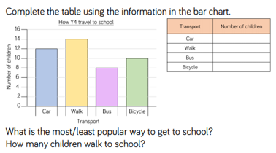  You could also produce a bar chart like this using data you can collect at home - e.g. the different colour cars you see outside, or the different types of wildlife or minibugs you can spot outside.  For a challenge, can you write a set of questions about the bar chart for someone in your family to answer?
Reading | 15 minutes | - Read your own book. Choose one paragraph in your book to practise reading fluently. You could do the monkey talking activity that we have done in class to see if you can read the same paragraph a few times, getting more fluent each time.
Spellings | 15 minutes | - Practise your spellings on Spelling Shed.  https://www.edshed.com
English | 30 minutes | - LO I can write a diary entry in character.  - Today, you are going to take on the role as Juliet. You are going to become Juliet! You need to try and think about how she would have been feeling when her new beloved husband, Romeo, was banished from Verona for killing her cousin.  - Write a diary entry from this moment in the story.  - Try to include:  - Thoughts, feelings and emotions  - Description of what has happened  - First person (using pronouns like I and we)  - Past tense
Science | 1 hour | LO I can research things in the home that use electricity.  1. Watch this video and count how many items you see that use electricity.  https://www.stem.org.uk/resources/elibrary/resource/30647/things-use-electricity  2. Go around your house and write a list or draw pictures of all of the different items that you can find that use electricity including mains electricity (using a plug) and battery powered electricity.  3. Draw a Venn diagram to show which items in your house are battery powered, which are powered by mains electricity, and are there any that could by powered by either battery or mains electricity?  4. If you could keep only one electrical item in your house, what would it be and why?

