Oliver’s Vegetables - Activities
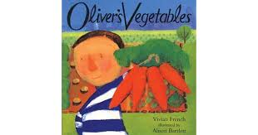

Choose any number of activities from the table below to do with your child over the course of the week.
Literacy Activities | - Listen to the story of Oliver’s Vegetables - https://www.youtube.com/watch?v=IhmqiEXe8dc  - Write a sentence to say which vegetable Oliver ate on each day, eg. On Monday, Oliver ate carrots.  - Write a shopping list for the fruit and veg your family needs this week  - Retell the story of Oliver’s vegetables, use the story sequencing cards to help if you want  - Write a letter to Oliver telling him about the vegetables you like and don’t like  - Make a list of all the vegetables you eat in a week  - Read some more stories about growing and eating vegetables (see vegetable book list for inspiration)
Maths Activities | - Count some vegetables! Or fruit. How many potatoes/carrots are there in a bag? How many apples are in the fruit bowl?  - Find some veg at home and order it by size. This could be by length, height or weight. Ask your child to explain why they have put it in that order. If you have scales, you could weigh the vegetables too.  - Carry out a vegetable survey – ask your family what their favourite vegetables are. Can you work out which is the family favourite?  - Make some vegetable repeating patterns  - Make up your own vegetable addition or subtraction problems  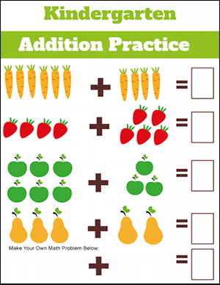  - Have you got a carrot? Can you find things that are longer, shorter or the same length as a carrot? Can you use the carrot to measure things? How many carrots tall are you?
Creative Activities | 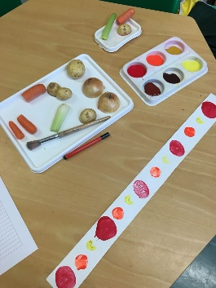  - Do some vegetable printing  - Make a fruit and vegetable rainbow: Draw a blank rainbow (or use the rainbow colour matching sheet if you have a printer) and fill each colour section with fruit or vegetables of the correct colour  - Look at the Giuseppe Acrimboldo PowerPoint. Have a go at drawing or making your own portraits using fruit and veg  - Make your own vegetables. You could use play dough, plasticine, clay or make your own salt dough ( see attached recipe)  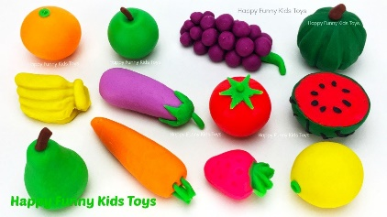  - Make a plate of healthy vegetables (or fruit)  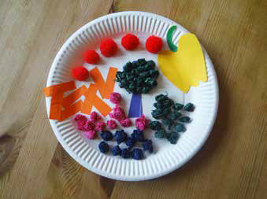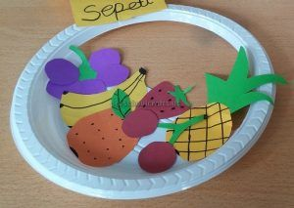
Sing some songs | Vegetable song - https://www.youtube.com/watch?v=BCBketJ6Ug8  One potato, two potato - https://www.youtube.com/watch?v=RbBuH4QlfOI  Harvest Samba - https://www.youtube.com/watch?v=NTdIrlTlXks  Cauliflowers Fluffy - https://www.youtube.com/watch?v=PukdaXUzgOU
Communication and language activities | - Talk about your own likes and dislikes (vegetables). Talk about how Oliver felt at different points in the story. How does it feel when you try out a new food?  - Play a listening and attention game with your child. Place a number of vegetables on a tray and cover with a blanket. Ask them to guess how many are there, then double-check by counting. Remove one of the objects - can they say which one has been removed?  - Provide a feely bag with lots of different fruits and vegetables inside it. Ask your child to put their hand in, choose one and then tell you what they can feel. Ask them to smell it and tell you the smell before finally looking at it and using their eyes to describe it. Introduce the vegetable names and new vocabulary too.
Cooking ideas | Rainbow pizzas - https://www.bbcgoodfood.com/recipes/rainbow-pizzas  Layered rainbow salad pots - https://www.bbcgoodfood.com/recipes/layered-rainbow-salad-pots  Veggie rolls - https://realfood.tesco.com/recipes/veggie-rolls.html  Carrot cake squares - https://realfood.tesco.com/recipes/carrot-cake-squares.html  Mini veggie burgers and salsa - https://www.bbc.co.uk/cbeebies/makes/i-can-cook-miniveggieburgersandsalsa  Homemade nachos - https://recipes.sainsburys.co.uk/recipes/snacks/homemade-nachos  Broccoli & tomato macaroni bake - https://recipes.sainsburys.co.uk/recipes/main-courses/broccoli-and-tomato-macaroni-bake  Cheese and vegetable muffins – see attached sheet

