Percy the Park Keeper - Activities
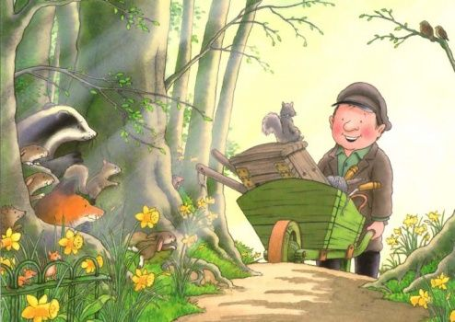

Choose any number of activities from the table below to do with your child over the course of the week.
Literacy Activities | - Listen to the story of Percy the Park Keeper – After the Storm, read by Nick Butterworth, the author –  https://www.youtube.com/watch?v=OfPj5_k2kZk  - Use the Percy stick puppets, or make puppets of your own, to retell the story of After the Storm (or a different Percy story).  - Have a look at the Percy story review. Write sentences or draw pictures to show what happened in the story.  - Write a list of all the different animals who live in the park with Percy  - Write a description of one of the animals without saying what it is. Ask someone to read your description and see if they can guess which animal you wrote about.  - What do you like doing at the park? Draw a picture and write about it. The Percy word mat could help you.  - Watch this animation of Percy the Park Keeper – After the Storm - https://www.youtube.com/watch?v=7dyCkleWRzo&t=20s  There are lots of other stories, some read by Nick Butterworth, and animations of the Percy stories on YouTube
Creative ideas | - Make some toilet roll woodland animals:  https://readandcreate.co.uk/percy-the-park-keeper-woodland-animals/  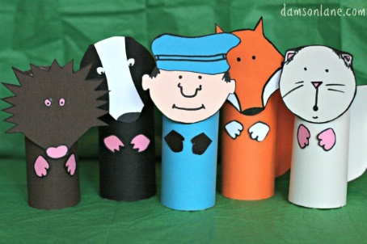  - Make a paper plate badger  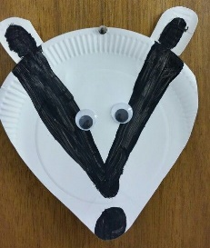  - Make some woodland creatures from pine cones:  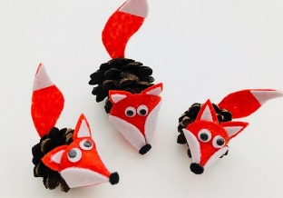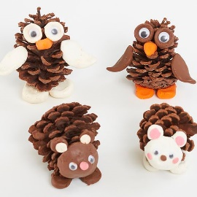  - Make a hedgehog from clay and twigs:  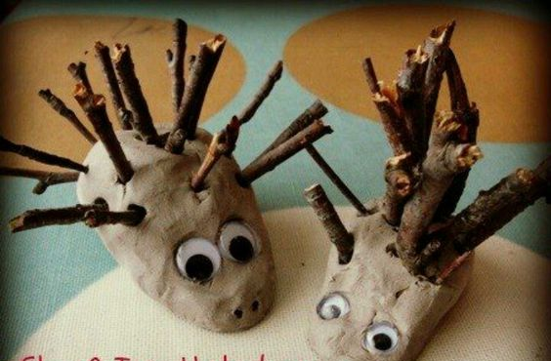
Cooking ideas | - Make food to take on a picnic to the park (or into the forest). You could make sandwiches, sausage rolls, rocky road – whatever your favourite picnic food is.  - If you’re feeling ambitious – A hedgehog cake:  https://www.bbcgoodfoodme.com/recipes/hedgehog-cake/  