Class 3 collected information about what transport students used to get to school. They have not put labels under the columns on the horizontal axis.

PART A
Use the clues to decide which transport matches each column in the graph.
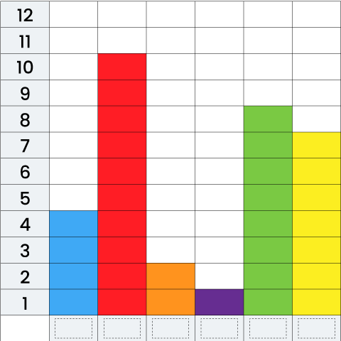

Clues:
• Twice as many people caught a bus as walked.
• One less person caught a train than caught a bus.
• The number of people who arrived by bike and bus together is equal to the number that arrived by car.
• Half the number who rode bikes used a type of transport not listed.
Teacher marked, show your work on the opposite page

PART B
What labels could you write for the x and y axis? What would be a good title for the graph? Write them down.

