The Lighthouse Keeper’s Lunch - Activities
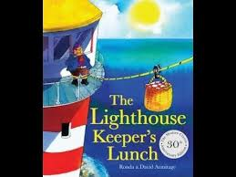

Choose any number of activities from the table below to do with your child over the course of the week.
Literacy Activities | - Listen to the story of The Lighthouse Keeper’s Lunch - https://www.youtube.com/watch?v=46wCRq50Wwg or watch https://www.youtube.com/watch?v=GqzEj_W4bUk  - Design a delicious and a disgusting sandwich: one for you and one for the seagulls  - Write a shopping list for the things you would buy for a picnic  - Retell the story of the Lighthouse Keeper’s Lunch (you could use the story props)  - Investigate lighthouses – you could draw a picture and write a sentence to share something you found out  - Write a list of the things Mr Grinling has to do as Lighthouse Keeper  - Draw and label pictures of Mr Grinling dressed for rain and sunshine  - Listen to The Lighthouse Keeper’s Cat https://www.youtube.com/watch?v=kSlaOU3Crts  - Listen to The Lighthouse Keeper’s Rescue https://www.youtube.com/watch?v=oBmVO-MlVrk  - Watch the Lego version of The Lighthouse Keeper’s Lunch https://www.youtube.com/watch?v=s8rAT2ZtUI8
Creative Activities | - Build a lighthouse – you could make a junk model or use any construction materials you have at home. What can you use for the light?  - Make a checked napkin by weaving paper 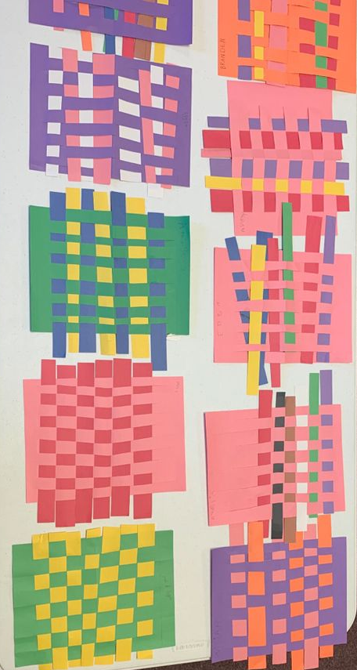  - Make a paper plate seagull  https://www.localfunforkids.com/home/preschool-summer-bird-craft-paper-plate-seagull.html  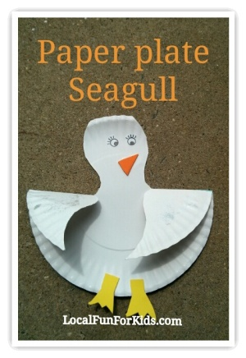  - Make some paper boats https://www.easypeasyandfun.com/how-to-make-a-paper-boat/  - Make a healthy lunch from playdough
Sing some songs | - My Lighthouse  https://www.youtube.com/watch?v=lFBZJGSgyVQ  - Row, row, row your boat  https://www.youtube.com/watch?v=-19tZJyi7xE
Science Activities | - Investigate light and dark – can you find somewhere really dark in your home. Have you got a torch you can play with?  - Glowing Stars investigation  - Make a string telephone  https://www.youtube.com/watch?v=DhdDdiO_km4  - Investigate things that float and sink  - Create a pulley like The Grinlings used to get the picnic basket to the Lighthouse
Cooking ideas | - Help make lunch  - Make your delicious sandwich  - Make a treat to go in a picnic lunch – you could try Apricot and White Chocolate Cereal Bars (which are delicious!)

